Encapsulation Program:
Student.cs:
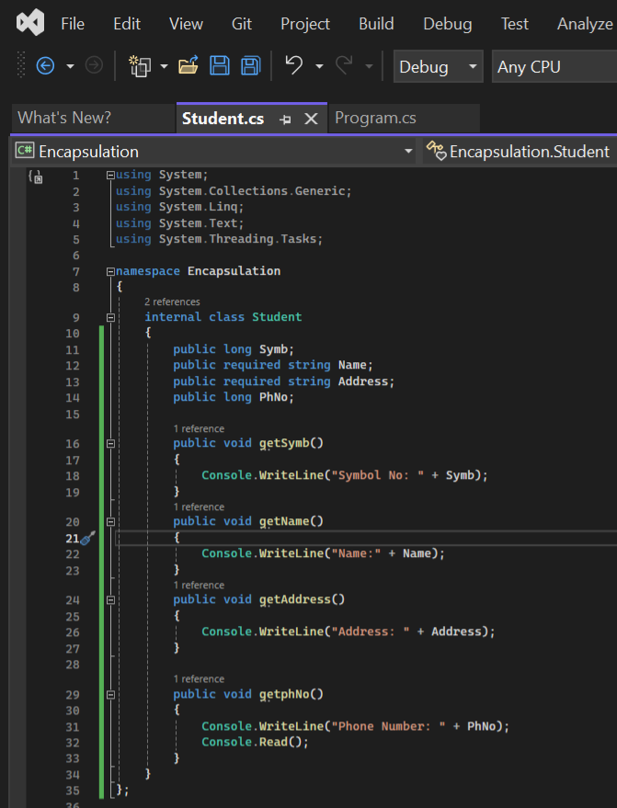

Program.cs:


Output:
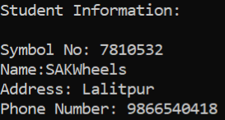
Practice Bank Program:
Banking.cs:
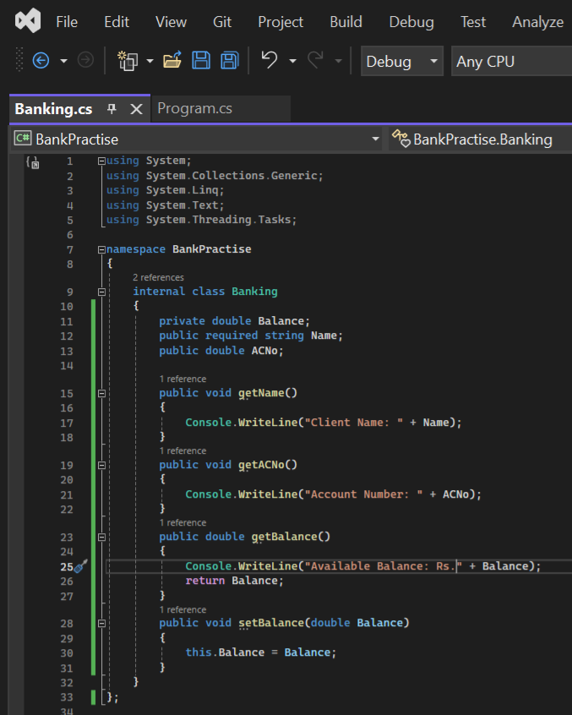
Program.cs:


Output:
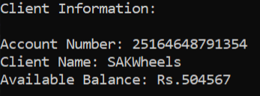

- Conclusion: Hence, it is observed that we can achieve "Encapsulation" in C# which also leads to data abstraction or hiding. This characteristic of data hiding provides greater program security and avoids unlimited data corruption.

